Creating spring application in Eclipse IDE
Simple steps to create the spring framework application project in Eclipse IDE.
- create the Spring project
- add maven dependencies to pom.xml file
- create the java POJO class
- create the applicationContext.xml file to provide the values
- create the Test class with public static void main(String args[]) method

Steps to create spring application in Eclipse IDE
Let's see the 5 steps to create the first spring application using eclipse IDE.
1) Create the Maven Project
Go to File menu - New - project - Maven Project. Write the project name e.g. firstspring - Finish. Now the java project is created.
2) Open pom.xml file which is available at the end in Project Explorer
There are mainly three maven dependencies required to run this application.
- org.springframework spring.core-6.0.11
- org.springframework spring.context-6.0.11
- org.springframework spring.beans-6.0.11
- How to add maven dependency – spring core in pom.xml
Google search – maven dependency spring core
Search and select 6.0 and click on it:
Click on Maven <dependency> - it will get copied automatically and then paste Ctrl+V
Inside the pom.xml file.
NOTE: Follow the images for more clarity.
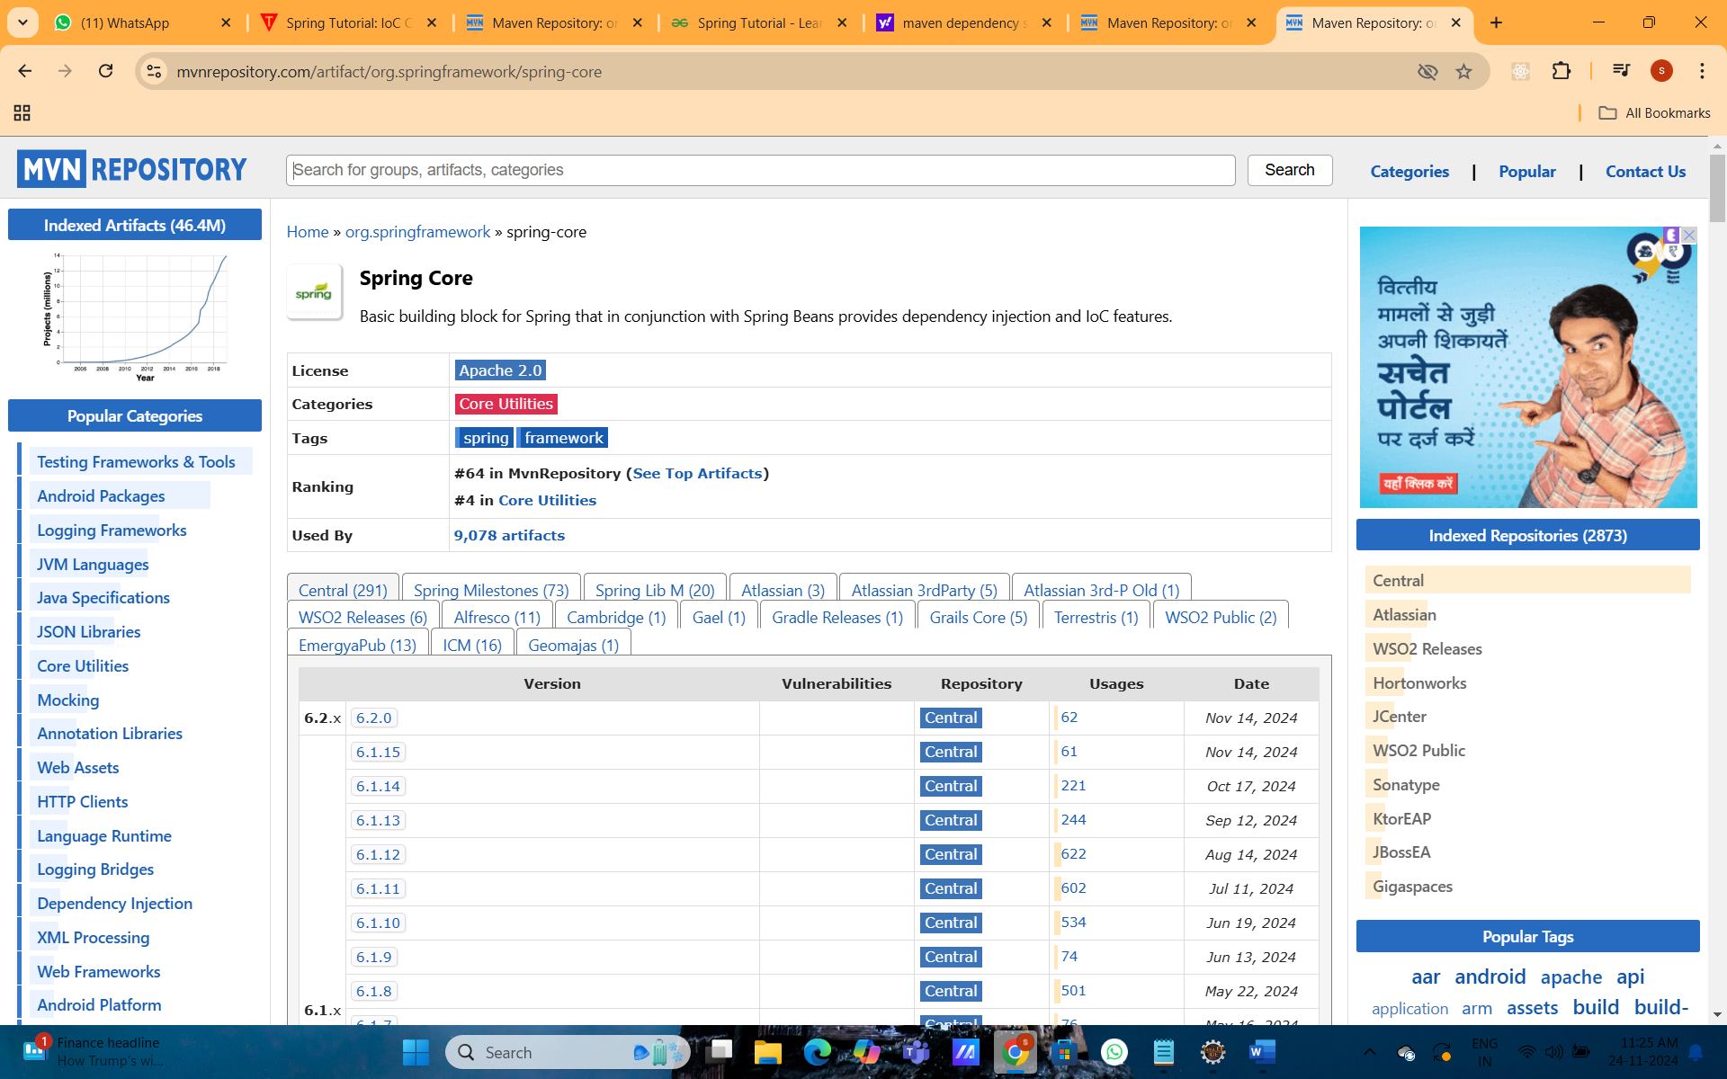

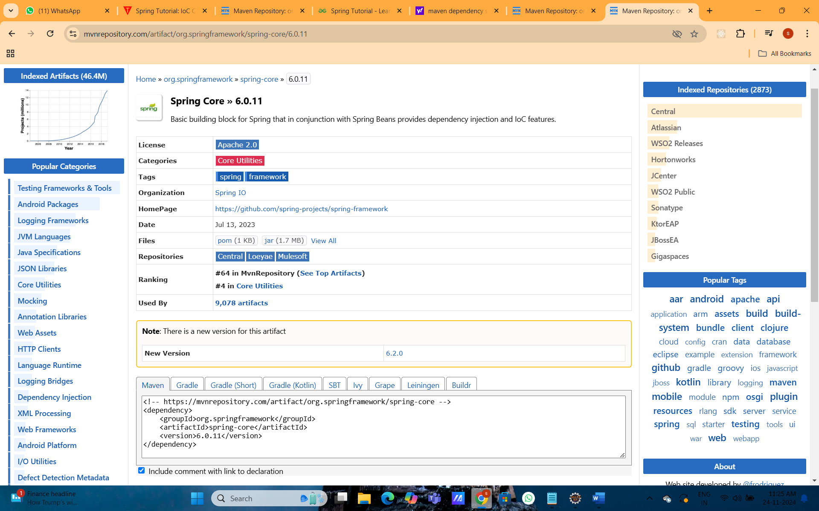

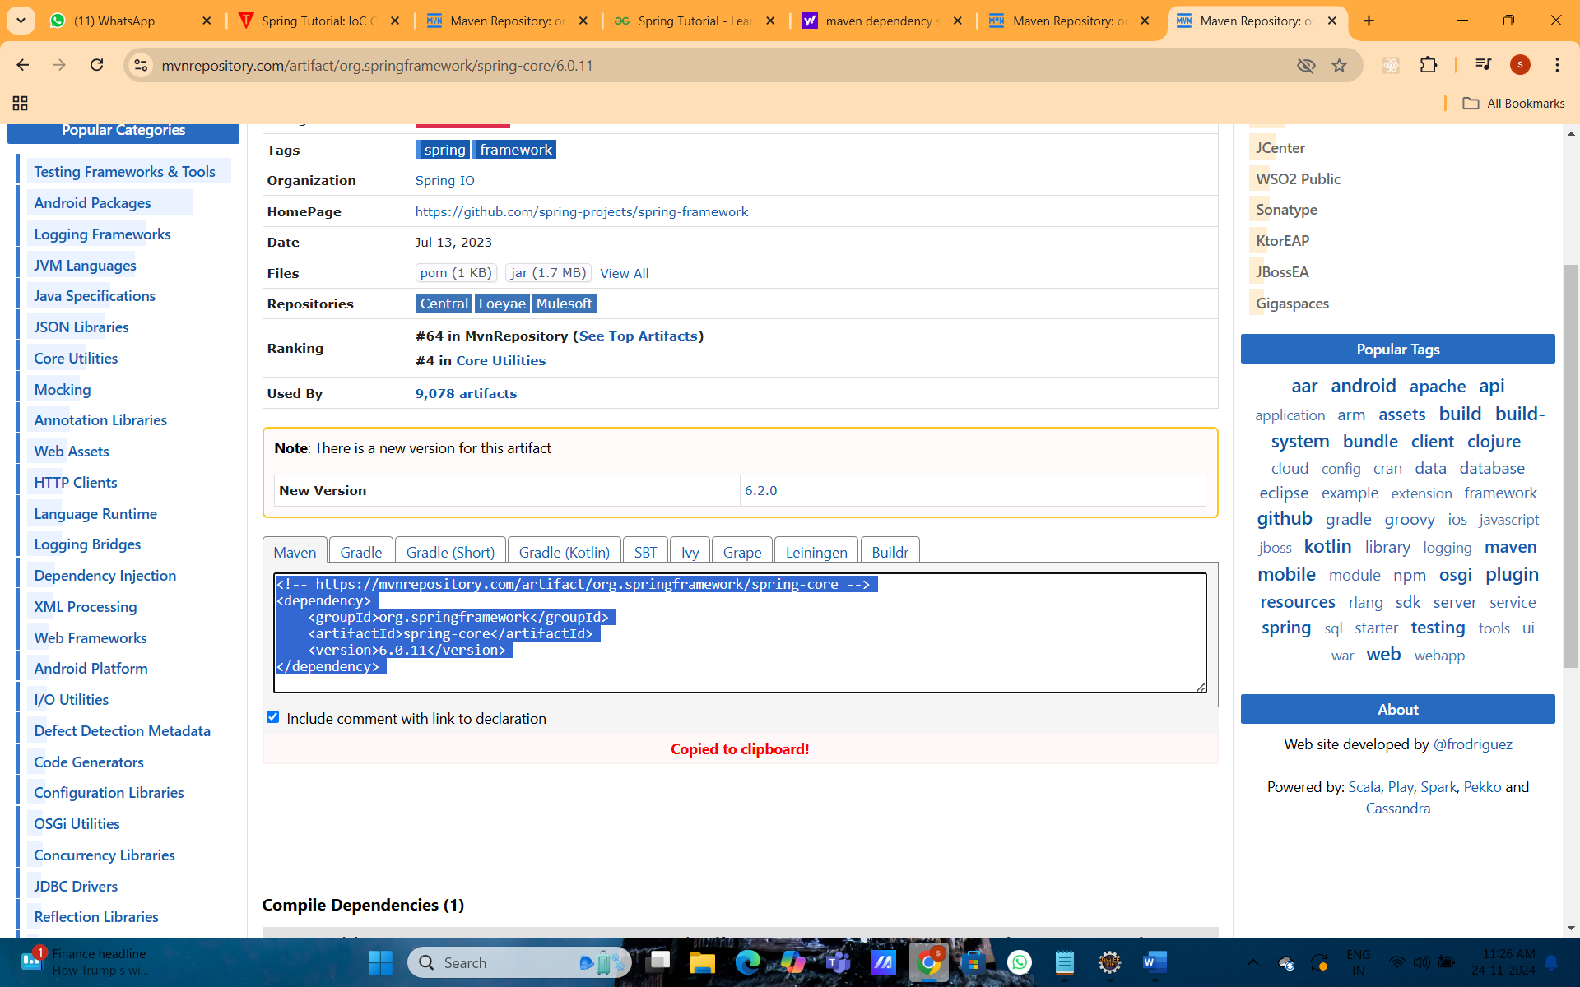

2. How to add maven dependency – spring context in pom.xml
Google search – maven dependency spring context
Search and select 6.0 and click on it:
Click on Maven <dependency> - it will get copied automatically and then paste Ctrl+V
Inside the pom.xml file.
NOTE: Follow the images for more clarity.

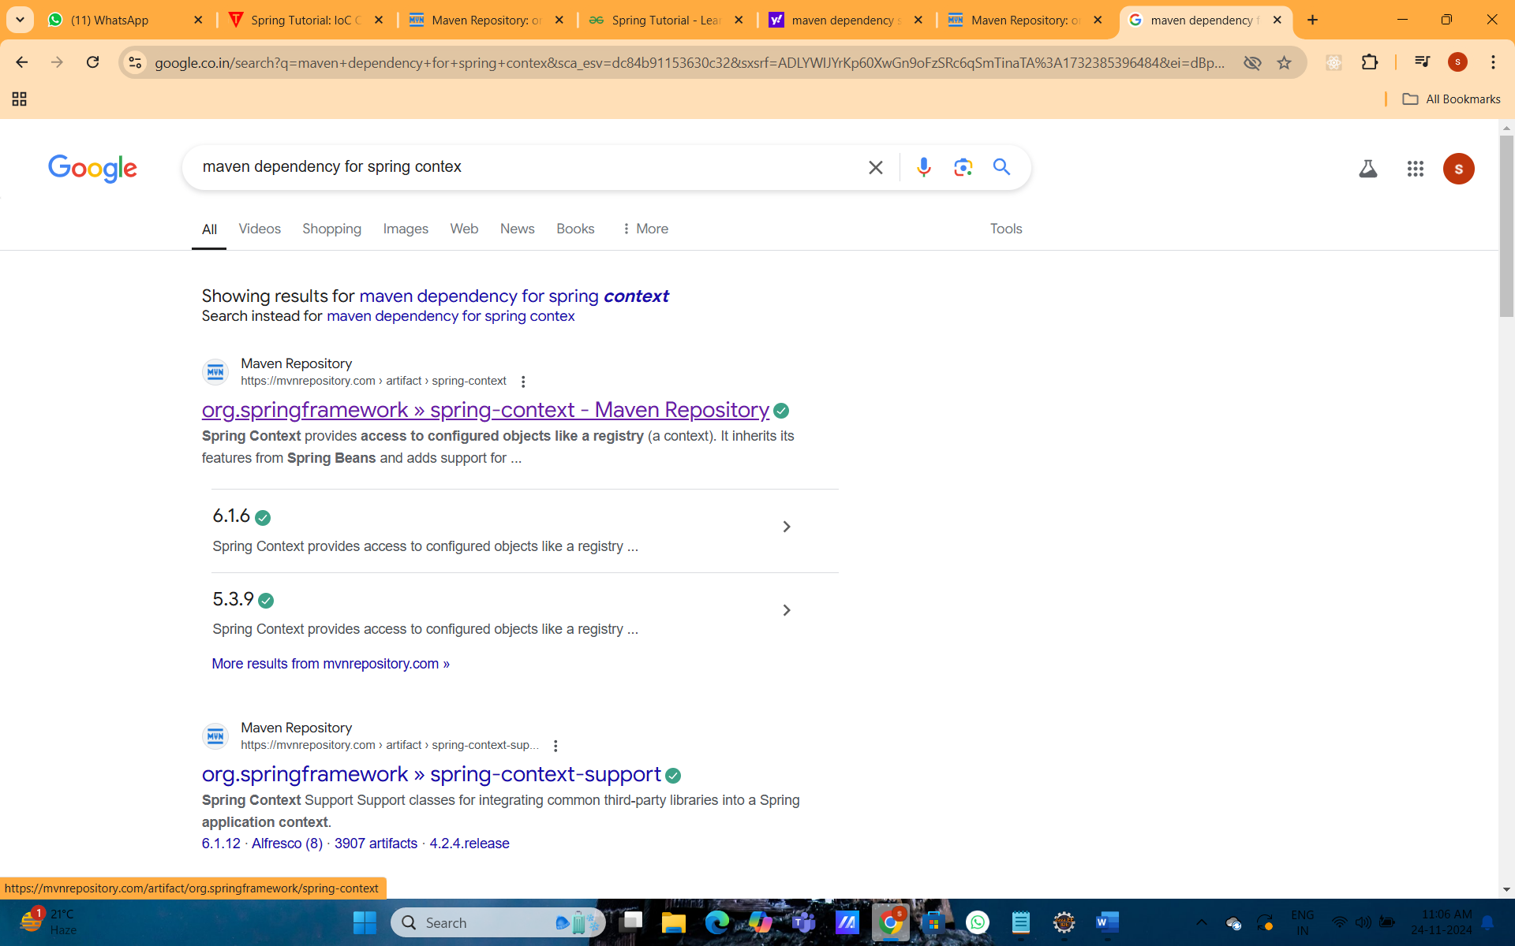
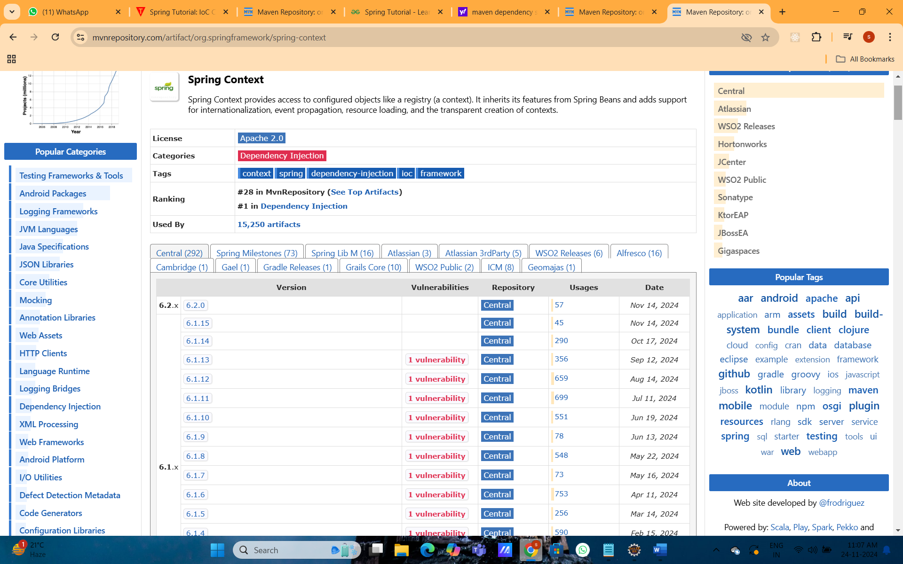

Search and select 6.0 and click on it:
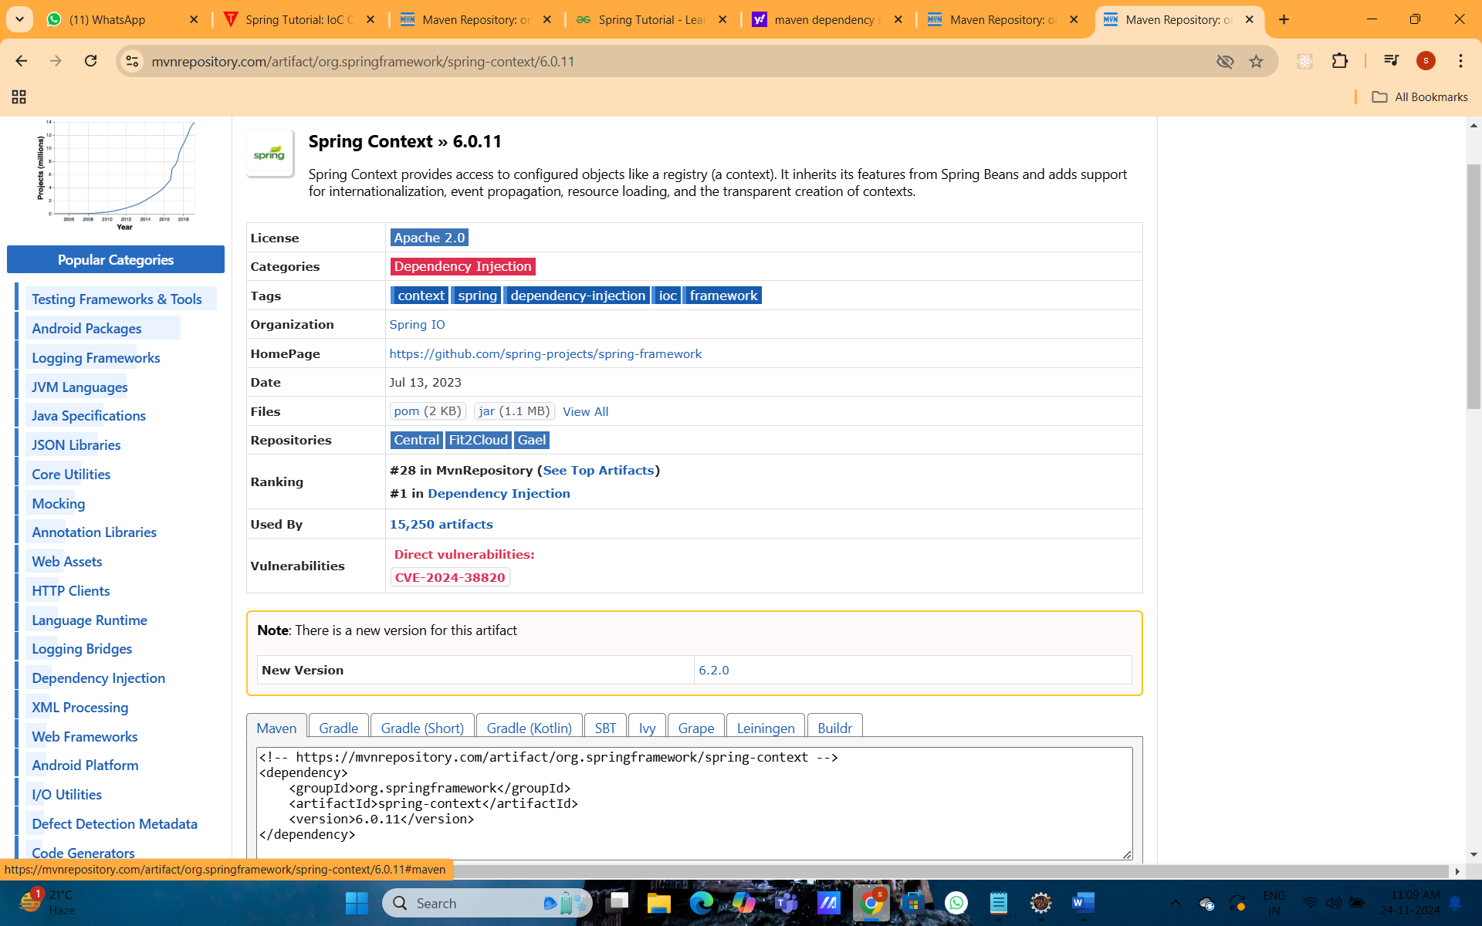
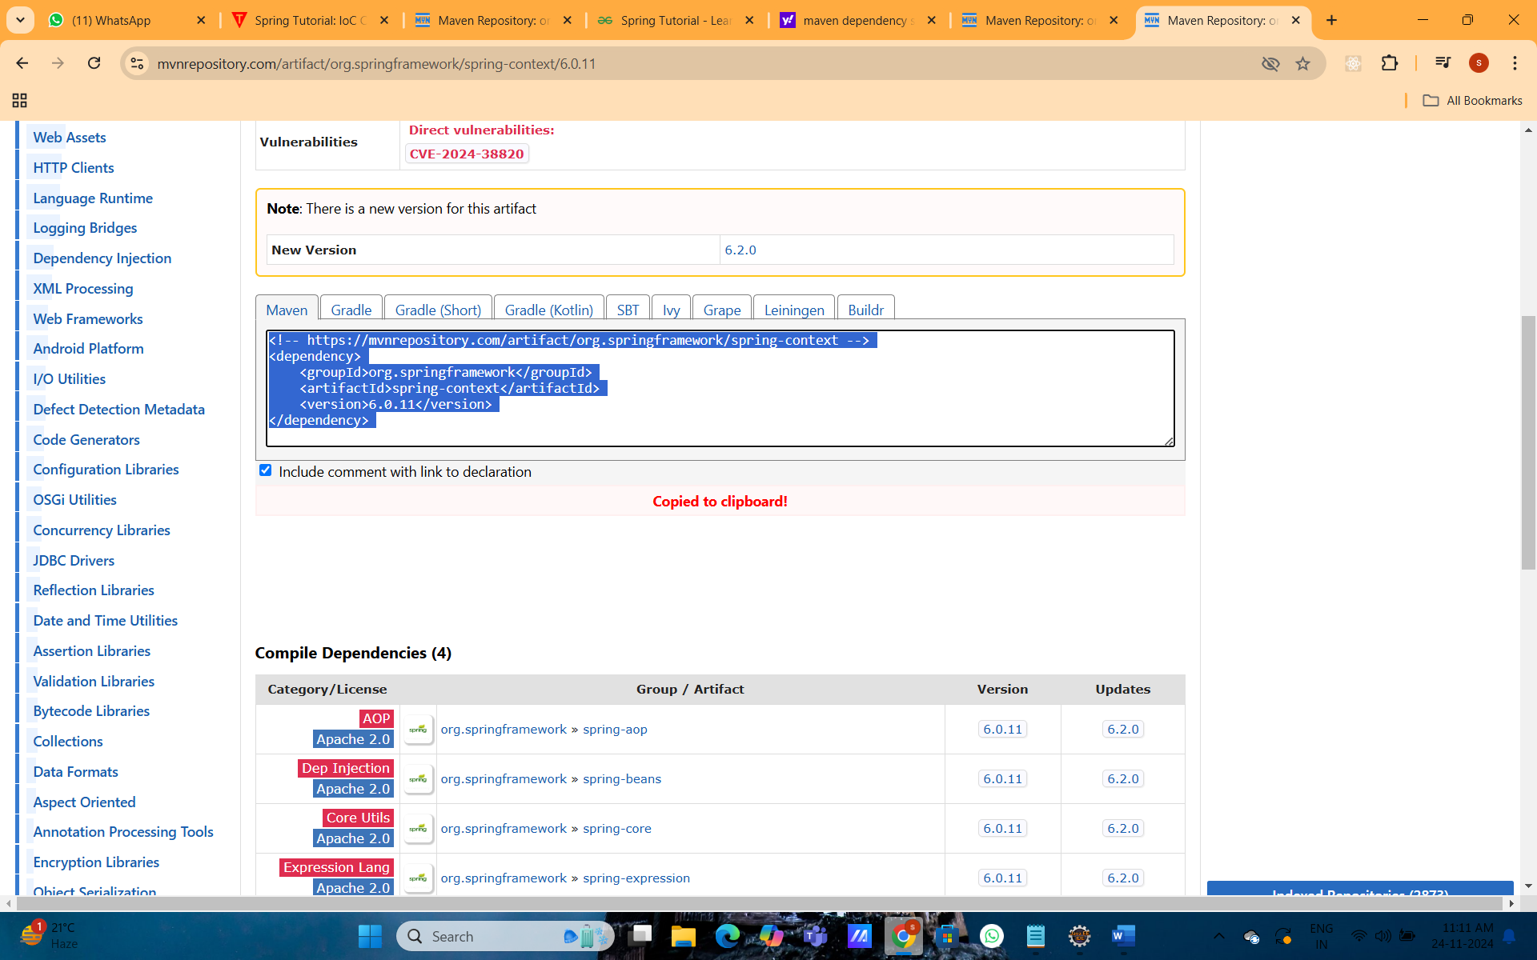
Click on Maven <dependency> - it will get copied automatically and then paste Ctrl+V
Inside the pom.xml file.


  - How to add maven dependency – spring beans in pom.xml
Google search – maven dependency spring beans
Search and select 6.0 and click on it:
Click on Maven <dependency> - it will get copied automatically and then paste Ctrl+V
Inside the pom.xml file.
NOTE: Follow the images for more clarity.

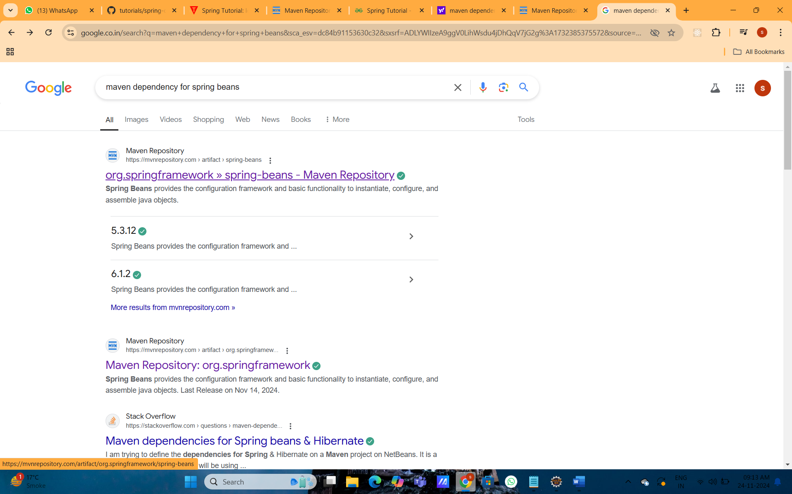
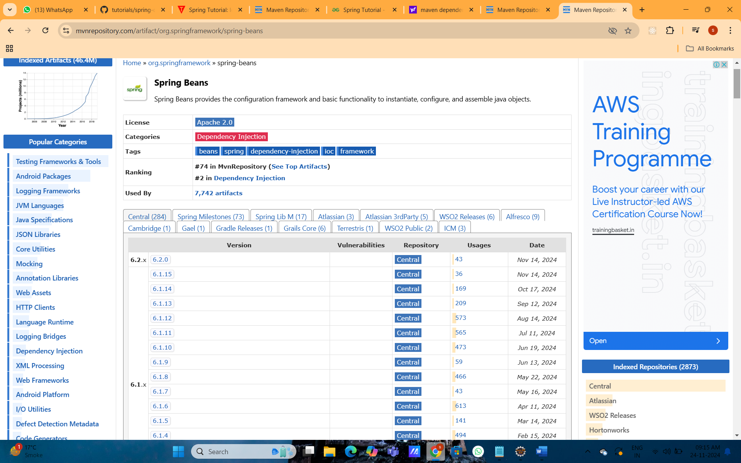
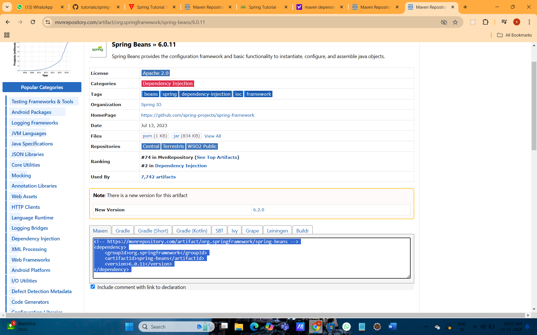

Finally pom.xml file content is as follows :
<project xmlns="http://maven.apache.org/POM/4.0.0" xmlns:xsi="http://www.w3.org/2001/XMLSchema-instance" xsi:schemaLocation="http://maven.apache.org/POM/4.0.0 https://maven.apache.org/xsd/maven-4.0.0.xsd">
<modelVersion>4.0.0</modelVersion>
<groupId>com.subbi</groupId>
<artifactId>demospring</artifactId>
<version>0.0.1-SNAPSHOT</version>

<!-- https://mvnrepository.com/artifact/org.springframework/spring-core -->
<dependencies>
<!-- https://mvnrepository.com/artifact/org.springframework/spring-core -->
<dependency>
<groupId>org.springframework</groupId>
<artifactId>spring-core</artifactId>
<version>6.0.11</version>
</dependency>
<!-- https://mvnrepository.com/artifact/org.springframework/spring-context -->
<dependency>
<groupId>org.springframework</groupId>
<artifactId>spring-context</artifactId>
<version>6.0.11</version>
</dependency>
<!-- https://mvnrepository.com/artifact/org.springframework/spring-beans -->
<dependency>
<groupId>org.springframework</groupId>
<artifactId>spring-beans</artifactId>
<version>6.0.11</version>
</dependency>
</dependencies>
</project>

3) Create Java class
In such case, we are simply creating the Student class have name property. The name of the student will be provided by the xml file. It is just a simple example not the actual use of spring. We will see the actual use in Dependency Injection chapter. To create the java class,
Right click on src - New – package – give name like demo.spring
Right click on src – package name – New - class - Write the class name e.g. Student - finish. Write the following code:
public class Student {
private String stu_name; // type this, private modifier for stu_name, datatype is String
private String colg_name; // type this, private modifier for stu_name, datatype is String
private String roll_number; // type this, private modifier for stu_name, datatype is String
// right click – slect Source – select -Generate Setters and Getters,
// following code will be automatically typed for you.
public String getStu_name() {
return stu_name;
}
public void setStu_name(String stu_name) {
this.stu_name = stu_name;
}
public String getColg_name() {
return colg_name;
}
public void setColg_name(String colg_name) {
this.colg_name = colg_name;
}
public String getRoll_number() {
return roll_number;
}
public void setRoll_number(String roll_number) {
this.roll_number = roll_number;
}
// you have to type this java method
public void display()
{
System.out.println("Hi, I am "+ stu_name+" from "+colg_name); }
}

This is simple bean class, containing only 3 attributes or property stu_name, colg_name, roll_number with its getters and setters method. This class contains one extra method named display()
it prints the student name and college name with Hi OR Hello message.

4) How to Create the applicationContext.xml file
-To create the xml file click on resources folder - new - other – XML - give the file name such as applicationContext.xml - finish.
-Open the applicationContext.xml file, and write the following code:
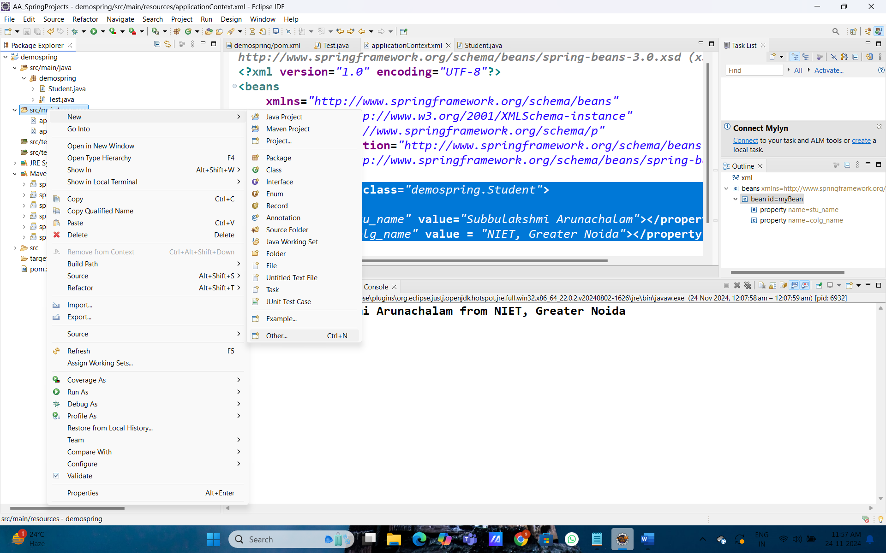
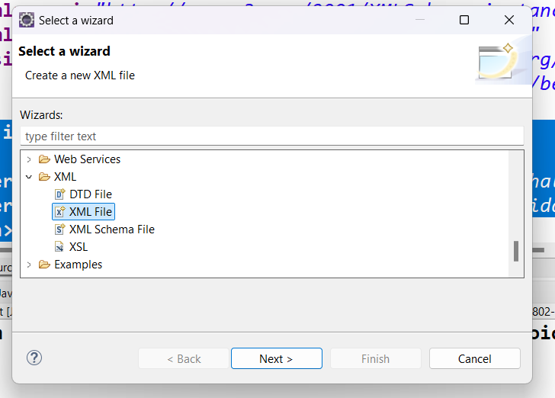
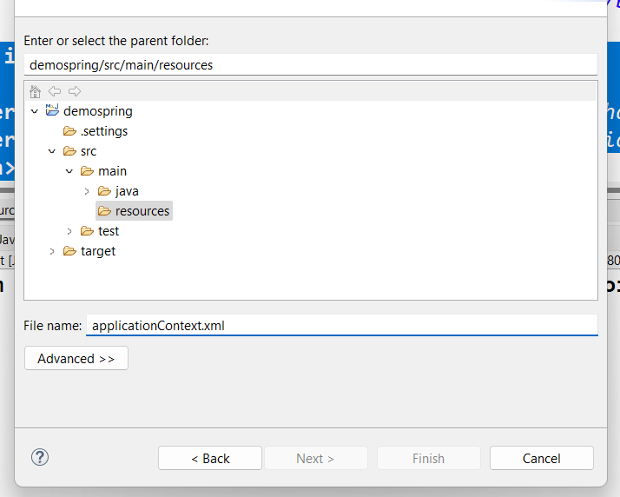
And copy paste the following content. Inside the applicationContext.xml file
applicationContext.xml file

<?xml version="1.0" encoding="UTF-8"?>
<beans
xmlns="http://www.springframework.org/schema/beans"
xmlns:xsi="http://www.w3.org/2001/XMLSchema-instance"
xmlns:p="http://www.springframework.org/schema/p"
xsi:schemaLocation="http://www.springframework.org/schema/beans
http://www.springframework.org/schema/beans/spring-beans-3.0.xsd">

<bean id="myBean" class="demospring.Student">
<property name="stu_name" value="Subbulakshmi Arunachalam"></property>
<property name="colg_name" value = "NIET, Greater Noida"></property>
</bean>
</beans>
The bean element is used to define the bean for the given class. The property sub element of bean specifies the property of the Student class named name. The value specified in the property element will be set in the Student class object by the IOC container. IOC container creates the object by the id = myBean. So object name is myBean ex. Student myBean = new Student(), will be automatically executed by Spring IOC container and we will not create object any where in the application.
This is Inversion Of Control- IOC means the responsibility of creating object is now with the spring framework and not with the Developer.
5) Create the test class
Create the java class e.g. Test. Here we are getting the object of Student class from the IOC container using the getBean() method of . Let's see the code of test class.
package demospring;
// COPY THESE 2 LINES ALSO AND PASTE IN YOUR Test.java file
import org.springframework.context.ApplicationContext;
import org.springframework.context.support.ClassPathXmlApplicationContext;

public class Test {

public static void main(String[] args) {
// COPY PASTE ONLY FROM HERE and PASTE INSIDE YOUR main method of your file
ApplicationContext context = new ClassPathXmlApplicationContext( "applicationContext.xml");
// Retrieve bean from Spring container
Student myBean = (Student) context.getBean("myBean");
// id from <bean> tag.
myBean.display();
//System.out.println(myBean.getStu_name());
}
}

Last Step:
Finally run the application to see the output in the Console Window:

